Day 05 - Referential Integrity & Cross Filter Check

1. Summary of Checks
The referential integrity and cross-filtering direction have been validated using DAX Studio and Power BI Model view. The relationships between 'Total Orders', 'Customers', and 'Plant' tables are one-to-many with single direction filters.

2. Verified Relationships in DAX Studio
Below are the confirmed relationships from the DAX Studio Verti Paq Analyzer tab:
- Total Orders [CustomerId] → Customers [ CustomerId] (One-to-Many, Single Direction)
- Total Orders [PlantId] → Plant [Plant Id] (One-to-Many, Single Direction)
- Total Orders [Date] → Auto-generated Local Date Table (One-to-Many, Single Direction)

3. Screenshots for Verification
DAX Studio Relationship Overview:
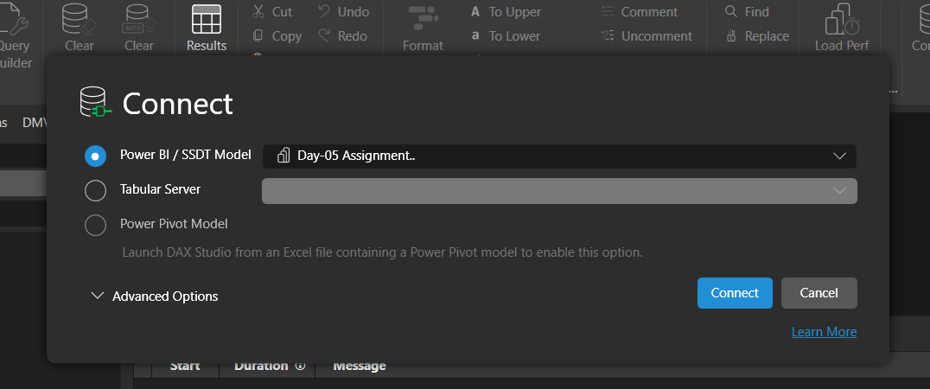
Verti Paq Analyzer > Relationships:
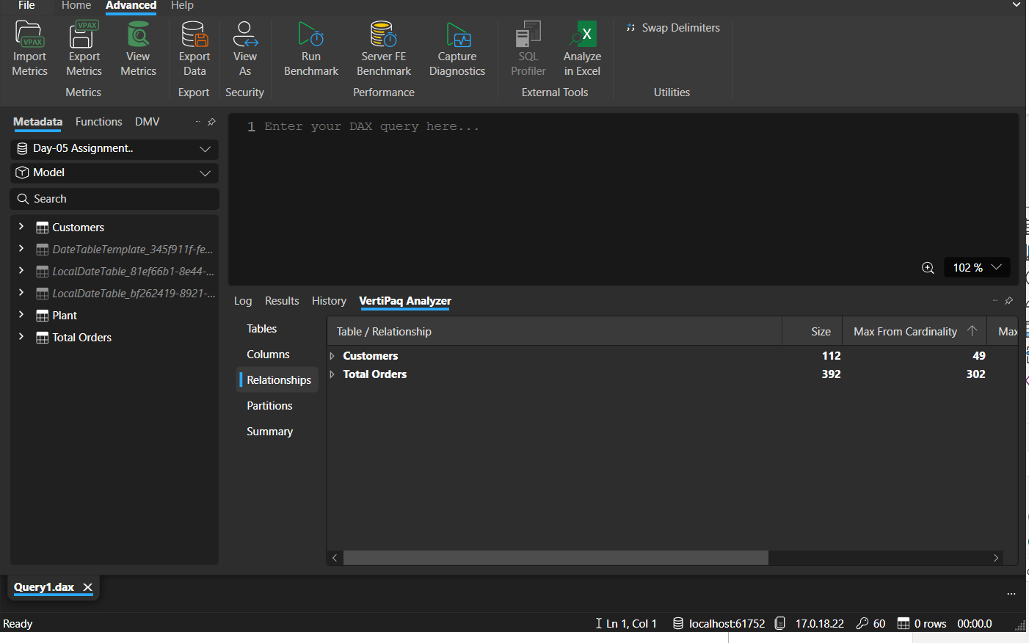
Model > Relationships expanded:
